# **LAPORAN TUGAS SISTEM TERDISRIBUSI**

**“Pemetaan Situs Web menggunakan Command DIG, NMAP, dan NSLOOKUP”**



## **OLEH:**

Nama : Muhammad Arif Abdillah

NIM : 09011182126008

Kelas : SK6PIL Indralaya

Dospem : Adi Hermansyah, M. T.

# **FAKULTAS ILMU KOMPUTER**

**PROGRAM STUDI SISTEM KOMPUTER**

# **UNIVERSITAS SRIWIJAYA**

# **2024**

* Openchatai.com

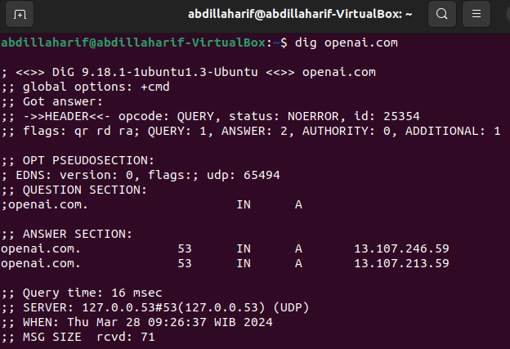

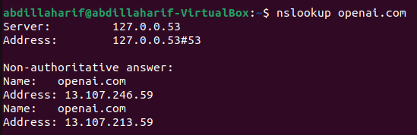

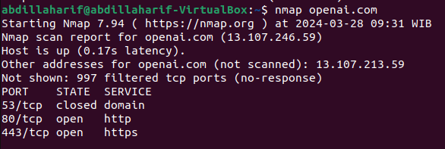

Server : 127.0.0.53

Address: 127.0.0.53#53

Non-authoritative: 13.107.246.59

Port: 53TCP (domain) / 80TCP (http) / 443 TCP (https)

* Kaggle.com

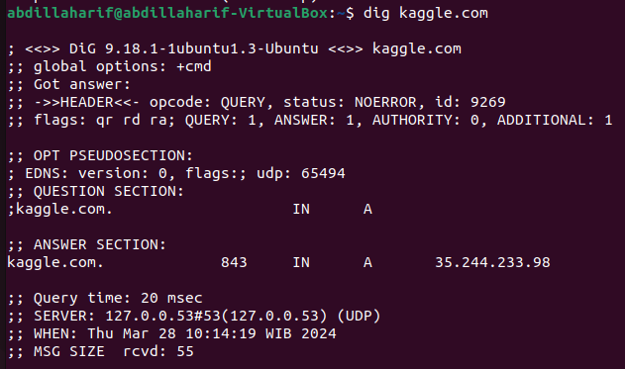 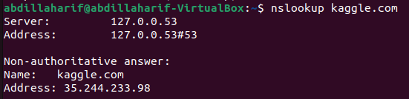 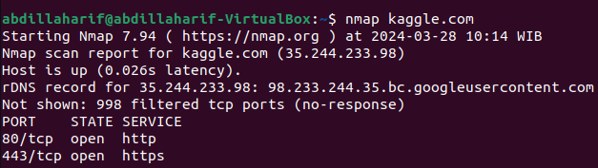

Server : 127.0.0.53

Address: 127.0.0.53#53

Non-authoritative: 35.244.233.98

Port: 80TCP (http) / 443 TCP (https)

* Spotify.com

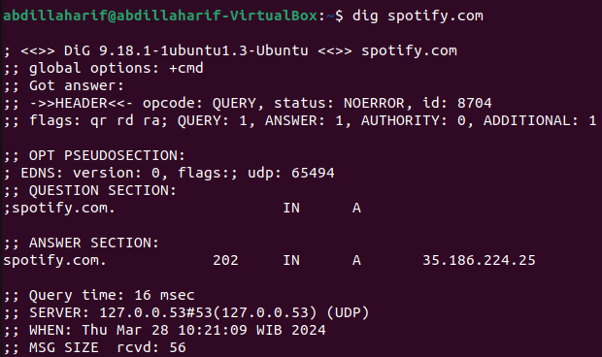

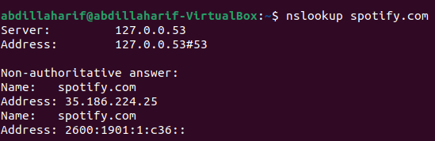 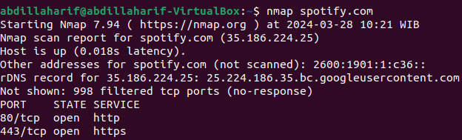

Server : 127.0.0.53

Address: 127.0.0.53#53

Non-authoritative: 35.186.224.25

Port: 53TCP (domain) / 80TCP (http) / 443 TCP (https)

* Youtube.com

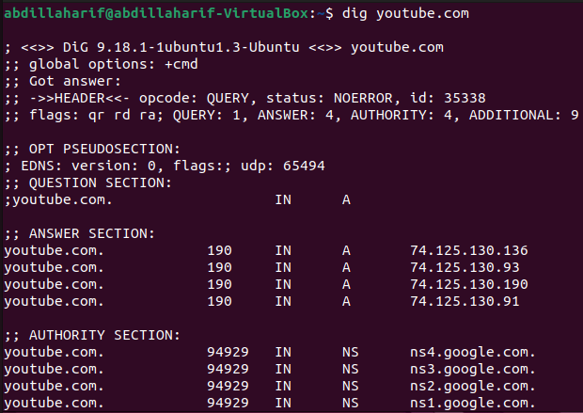

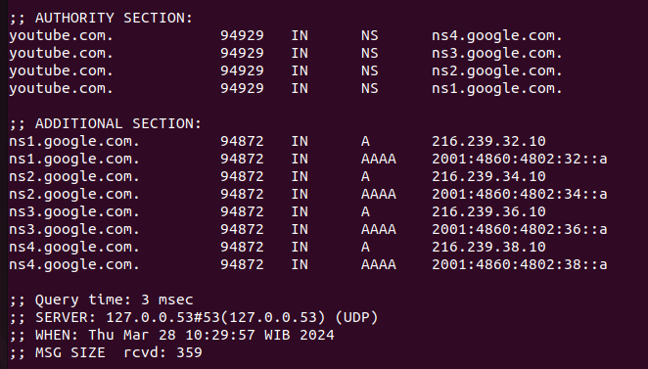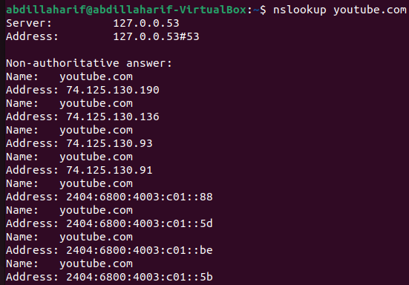

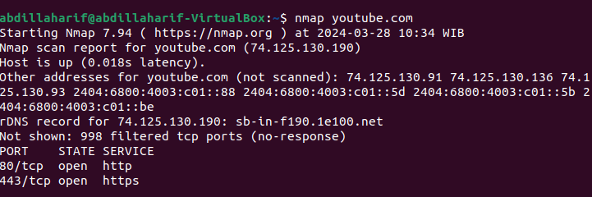

Server : 127.0.0.53

Address: 127.0.0.53#53

Non-authoritative: 74.125.130.190 .etc

Port: 53TCP (domain) / 80TCP (http) / 443 TCP (https)

* Google.com

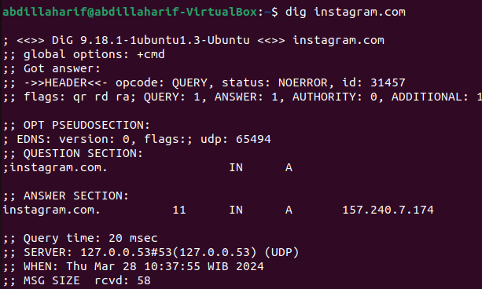

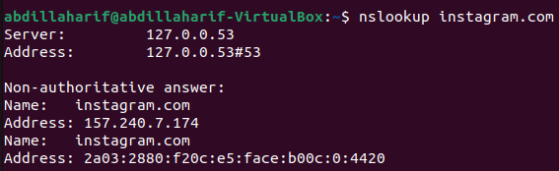 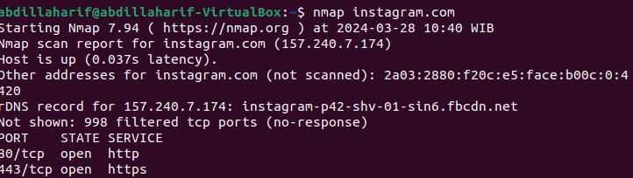

Server : 127.0.0.53

Address: 127.0.0.53#53

Non-authoritative: 157.240.7.174

Port: 53TCP (domain) / 80TCP (http) / 443 TCP (https)